Hi

In case you use an antivirus software, please ignore if the add-on is shown as malware or something. The add-on is safe.

The app is not signed(refer to the images in the [Github URL](https://github.com/medhachaitanya/PureBatteryAddOnSetup)) so few antivirus vendors might tag unsigned applications that start-up on windows restart as malware. You may safely ignore it.

If you are curious and would like to know more about it, please proceed reading. Otherwise you are done. Have a good day.

**How does an antivirus software treat/tag another software as a malware?**

First, the antivirus checks if the software starts automatically on windows startup/restart -> which is **YES** to show the battery percentage in the tray.

Second, the antivirus checks if the software runs all the time -> which is a **YES**to update the battery percentage in real-time.

Third, the antivirus checks if the software is signed with a certificate -> which is a **NO** for Pure battery add on.

If the answers for all the points above is a yes, then it is treated as a trusted software.

Well, coming back to Pure Battery Add on, the 3rd point above is a **NO**.

To get this sorted, I need to purchase a **digital certificate**, sign and distribute the software along with the certificate inside the setup file.

Well, to purchase a certificate I need to spend at least 400$ and I didn't want to spend that huge amount on a certificate that really doesn't matter.

I’m a graduate student and I make around 40-60$ at a max per month from Pure Battery and 400$ is a huge investment from my pockets. So, I have released it without a certificate which is why few anti-virus software's might show as a malware/threat as the Pure Battery Add on setup file is not signed.

You can trust me; the application is totally safe. Attached the screenshots below from famous antivirus vendors apologizing for treating the software as a Malware or a threat. 

**PTO**

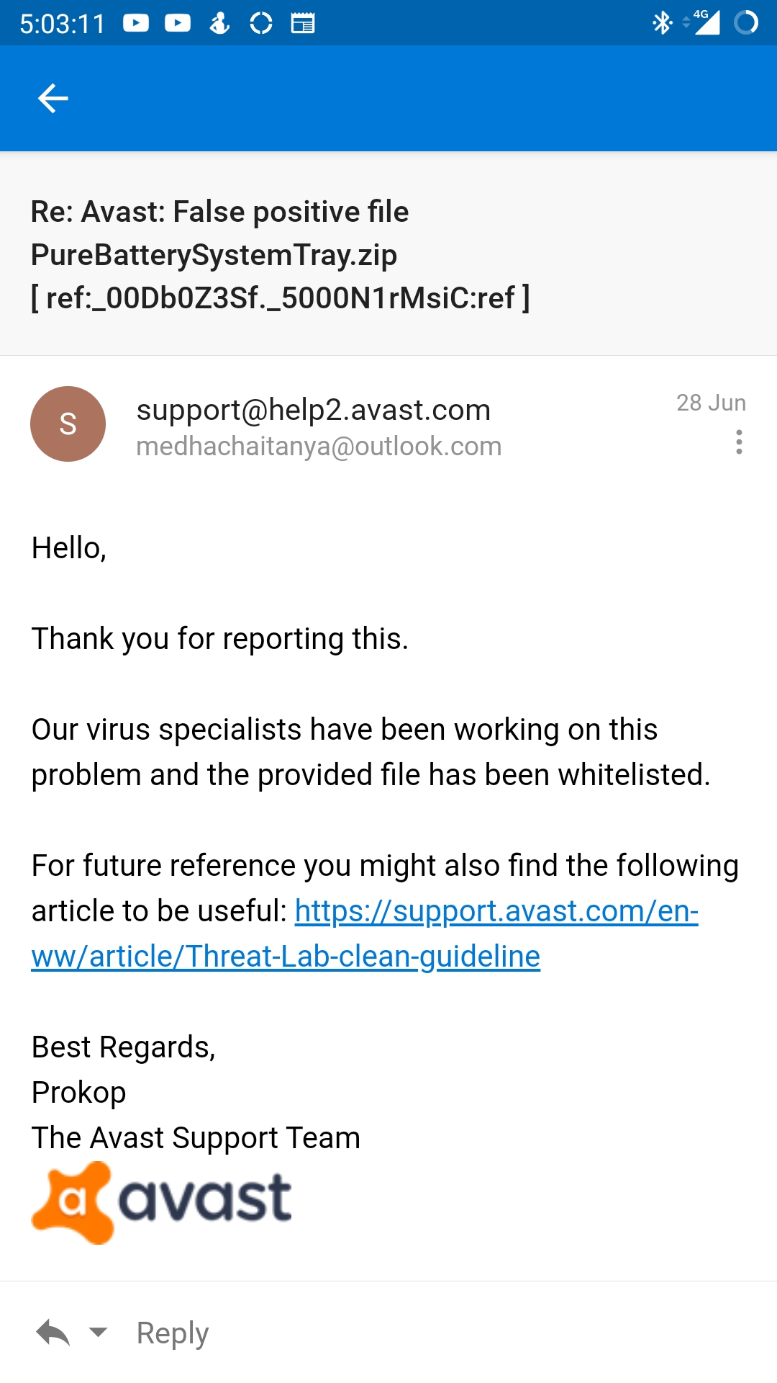  
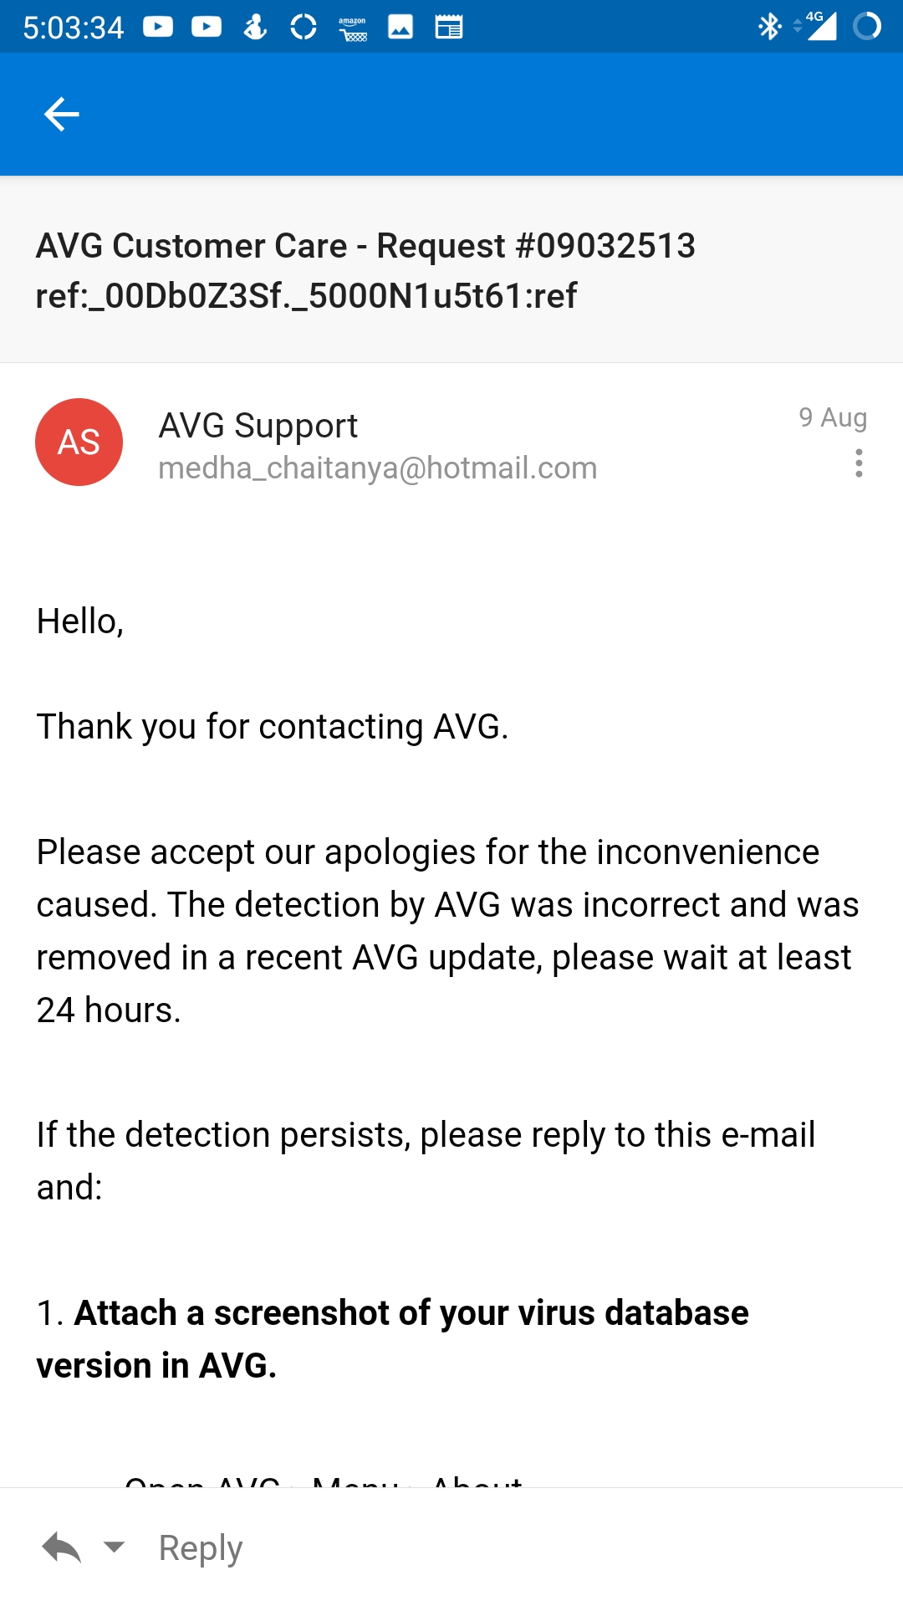  
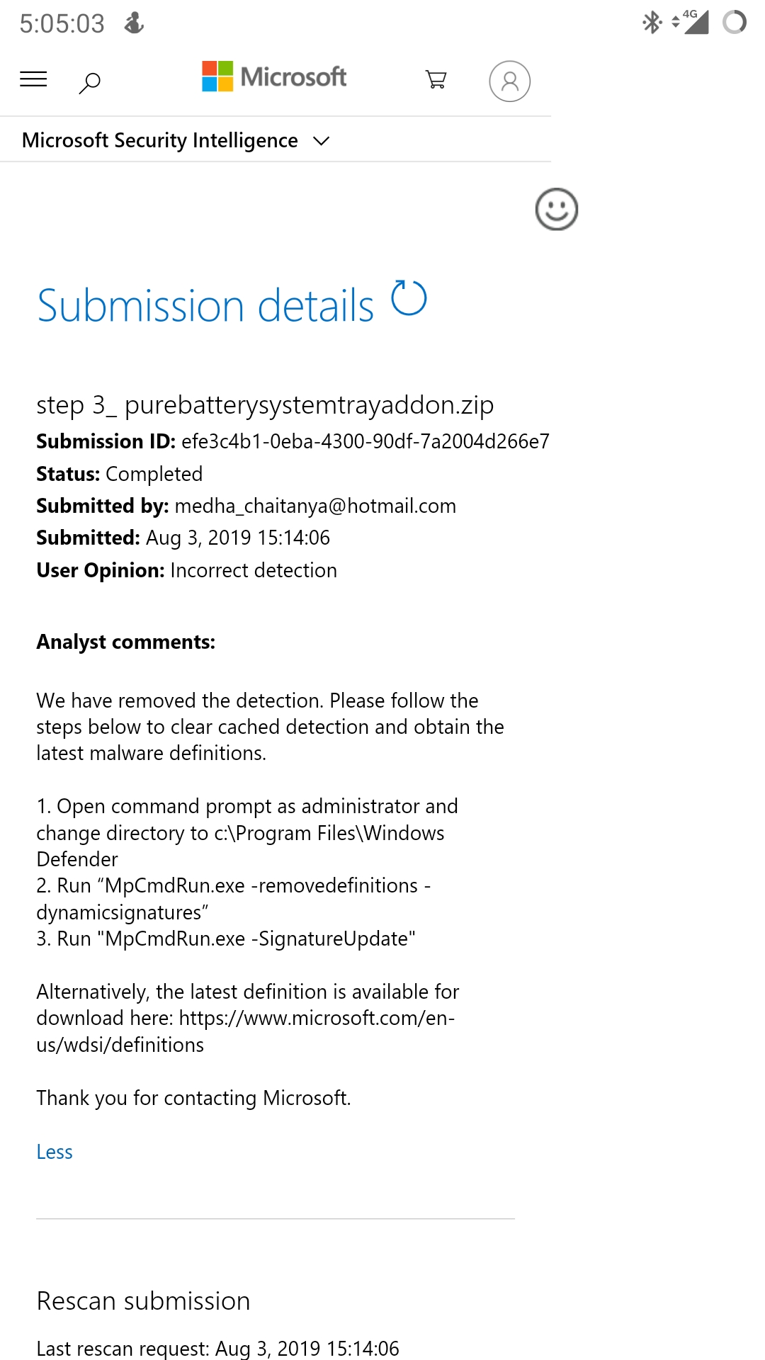

I tried to give a good software for free, but it seems like the world doesn't let people give things for free unless there's some way of money involved. This is a clear case of an obligation to purchase a hefty 400$ certificate and sign the application which is not needed.

I hope this document made you learn something. Feel free to mail [medhachaitanya@outlook.com](mailto:medhachaitanya@outlook.com) if you have any more questions. I would be happy to answer them.

If you still feel unsafe about the add-on, well then, don’t install it. 😊

I have released the software to the public only after sorting out all these issues.

If you liked the app, please do make a purchase and help me for its further development.

Thank you so much for your time.